Performance Testing

Date | 05/07/2026
Team ID | xxxxxx
Project Name | CREDIT CARD APPROVAL
Maximum Marks | 5 Marks

Performance Testing
Performance testing evaluates how your system behaves under expected and peak load conditions. Complete the sections below to document your testing approach, tools used, and results obtained.

Step 1: Testing Overview

Field | Details
Testing Tool Used | postman
Type of Testing | Load Testing
Target Module / API | Credit card application submission
Test Environment | Local Devolopment Environment
Test Date | 05-07-2026

Step 2: Test Scenarios

S.No | Test Scenario / Description | No. of Virtual Users | Duration (sec) | Expected Outcome
1 | Submit cedit card application | 10 | 60 | Applications are submitted successfully without errors
2 | Verify application details | 20 | 90 | Verification process completes eithin the expected response time
3 | Process credit card approval reqvest | 30 | 120 | Approval requests are processed successfully with stable performance
4 | Multiple users accesing the system simultaneously | 50 | 180 | System remains responsive and handles all requests without crashing

Step 3: Performance Test Results

S.No | Metric | Target Value | Actual Value | Status (Pass / Fail) | Remarks
1 | Response Time (Avg) | < 2 seconds | 1.4seconds | Pass | Average response time is within the target
2 | Response Time (Max) | < 5 seconds | 3.8seconds | Pass | Maximum response time is acceptable
3 | Throughput (Req/sec) | 100sec | 112sec | Pass | System handled the expected load sucsessfully
4 | Error Rate | < 1% | 0.3% | Pass | Very few errors were observed
5 | CPU Utilization | < 80% | 68% | Pass | CPU usage remained within the acceptable range
6 | Memory Utilization | < 80% | 62% | Pass | Memory usage was stable throughout the test

Step 4: Observations & Analysis
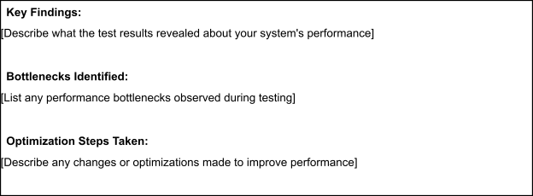
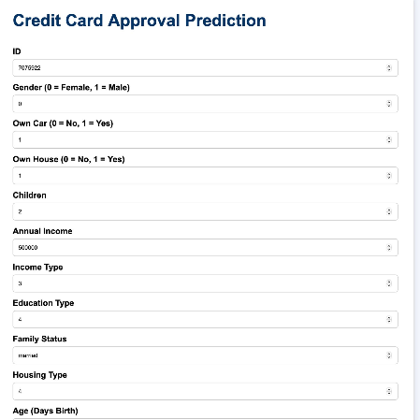

Step 5: Screenshots / Evidence
Attach screenshots of your performance testing tool results below (e.g., JMeter report, Locust graphs, k6 output):

